**SHORTER ATTENTION SPANS;**

**AN IN-DEPTH EXAMINATION OF THE EFFECTIVENESS**

**OF SHORT ADVERTISEMENTS ON DIGITAL NATIVES**

Hanchette, Jayce

**UNIVERSITY OF NORTH TEXAS**

Thesis Presented for

The Honors College

**Supervisor of Thesis**

Dr. Thuy Nguyen

**Abstract**

The differences in the effectiveness of short and long advertisements have a correlation with the shrinking attention span of digital natives. The current attention spans of digital natives are at 8 seconds and decrease as they consume more content on the internet. Because of this, shorter advertisements have been proven to be more effective in targeting both Generation Z and Millennials on apps such as TikTok and YouTube. Previous research has focused on either the comparison of short and long advertisements and attention spans, but not directly linking the two ideas together. This research collected data on Generation Z consumption patterns in relation to attention spans to find if there is a correlation between the two ideas. Out of 223 participants, 38.6% of the Generation Z Digital natives did not retain or correctly retain any of the brands shown immediately after the videos were shown. Our findings indicate that there is a correlation between effective recall of brand information and attention span relating to Generation Z and Millennials.

**Introduction**

The world of marketing is an everchanging field intended to grab attention quickly for the most profitable results. Short, informative advertisements have become the new standard as consumers’ average attention span is only 8 seconds, causing social media to stray away from longer content. (Subramanian, 2018). One of the most popular examples of this phenomenon is the ever-decreasing length of YouTube advertisements. YouTube ads started at 30 seconds, then moved to two 15-second ads, to one 15-second ad, to even as low as 5-second ads. The transition from longer to shorter advertisements has opened a newer era in the digital revolution, especially with the younger generation. This is due to their different and distinctive consumption patterns in comparison to generations X (born between 1965 and 1980), baby boomers (born between 1955 and 1964), and the silent generation (born between 1928 and 1945).

Generation Z (born between 1996 and 2015) and Millennials (born between 1981 and 1996), have distinctive consumer behavior in comparison to generations before because they are both digital natives or those of generations born or raised during the age of digital technology (Munsch, 2021). These two generations have grown up with technology, thus influencing almost every aspect of their lives (i.e. communication, activity levels); this is even more influential regarding how they consume any type of media as many traditional methods of advertising have been proven ineffective at capturing their full attention. This distinctive behavior of consuming advertisements and social media creates a dilemma with marketers on how to specifically target these younger audiences.

Past research has created a new definition to target and capture the full attention of a consumer called the “attention economy”. The attention economy is a technique used by market analysts where human attention is treated as a rare commodity by applying economic theory to managing information (Sen, 2021). The basic characteristic of the attention economy is a consumer’s attention capacity, which is formally represented as the relationship between stimulus exposure and the attention level of an individual (Falkinger, 2007). An example of measurable information in an attention economy are known as likes, time watched, shares, and saves. These aspects can be counted and applied to economic theory to measure how engaged the audience members are with the content. With the use of the attention economy and attention capacity, patterns of behavior in digital natives can be quantified and examined.

Therefore, the purpose of this study is to examine the shorter attention economy of digital natives by comparing the effectiveness of short advertisements to the diminishing returns of long advertisements. Strategies of short versus long advertising, attention economies, measurements of advertising effectiveness, and the difference in effectiveness between short and long advertisements will be included in the proposed study. Examining short advertising’s rise in popularity in correlation with the shorter attention spans of the younger market will further assist companies who wish to penetrate this market with short advertisements. The following research questions will be addressed:

1. What are the differences in effectiveness between short and long advertisements?
2. How are attention economies related to Generation Z and Millennial digital consumption patterns?

**Review of Literature**

**The Attention Economy**

Within the marketing world, capturing the attention of a target audience through advertisement is not an unfamiliar place for a marketing team, but rather a necessity. Through the use of attention economies, exploring the target audience’s attention capacity is measurable and can be applied to marketing techniques. An attention economy consists of two types of agents; the company that sends signals to earn attention and the receivers that are exposed to the signals. The receivers are the audience characterized by their attention capacity; this is represented as a relationship between stimulus exposure and the attention level of an individual (Falkinger 2007). Attention economies are also used as a technique for information management that treats human attention as a rare commodity by applying economic theory to managing information (Sen, 2021). Ultimately, the attention economy is a way to characterize attention in a way that is measurable to a company for easier comprehension. Given the diversity of advertising audiences (e.g. men, women, children, Generation Z), audience size will impact attention capacity. For example, larger audiences are more likely to have attention capacity because some audience members may be inattentive given that there are more individuals within the audience to devote attention to an advertisement (Fischer and Smith, 2020). Conversely, avid audiences interact more enthusiastically with topics that interest them in a consistent manner (Fischer and Smith, 2020). Once attention is gained based on a consumer’s capacity with the capability of attracting attention again, this idea makes up the attention capital within an attention economy (Falkinger, 2007).

When Attention economies are applied to advertising, it provides companies with significant information that can aid the process of advertising. Within the new digital era of the world, information is a constant, as it is all around through social media, television, or posted fliers around the city. However, an overload of information causes negative consequences such as increased distraction and less retention of overall information (Subramanian, 2018). For example, as the quantity of digital information increases, the level of human attention decreases due to information overload, distractions, and selective attention (Sen, 2021). These distractions are frequent, given that young adults (age 18-24) frequently reach for their phones when they are bored, check their phones every 30 minutes or less, and use their phones when they are watching TV (Subramanian, 2018). An overload of information causes negative consequences such as increased distractions and less informational retention, which is observed with eye movements and questionnaires (Weibel, 2019). Furthermore, advertisements presented on TV versus YouTube led to an increased number of eye movements during the YouTube advertisements, which demonstrated that more attention was allocated to the TV screen (Weibel, 2019). Their data also presented that TV attracts more attention than a smartphone, as there are more attentional resources with fewer distractions directed to the TV than to YouTube on a smartphone (Weibel, 2020). Information, distractions, and selective attention are threats to a marketing video’s attention economy.

In recent years, a mobile application that expertly harnesses the attention economy has appeared: TikTok. TikTok and Vine (an older but similar application) use shortened content of under 15 seconds to grab attention successfully. These applications were successful as their average content length was around 7 seconds, used algorithms, and harnessed the attention economy successfully. Vine’s shorter advertisement success pushed the short advertising idea into other apps like music.ly and finally TikTok, which is now a popular advertising social media platform (Anderson, 2020). Currently, TikTok is well known for its breakout algorithmic practices, causing users to find videos they pay the most attention to through view time, likes, shares, and saves (Abidin, 2020). Their algorithm measures users’ engagements, patterns, and routine behavior because repeated actions will trigger the platform’s algorithm to work in the consumer’s favor, providing them with content they already or will enjoy and engage with (Abidin 2020). TikTok’s success eventually influenced other platforms to come out with short content areas on their platforms as well, such as Facebook reels, Instagram reels, and YouTube Shorts (Anderson, 2020).

The algorithm takes advantage of Fischer and Smith’s concept of the avid audience within the attention economy to garner positive attention to possibly go viral (Fischer & Smith, 2020). Given the rise and ever-present use of these technologies, understanding the type of advertisement and targeted audience is an important part of creating traction for an advertisement. The algorithmic management on certain social media platforms that analyze the consumer attention economy helps maintain advertisement traction. Millennials and Gen Zs are found to be digital multitaskers where attention grabbers are more effective than traditional means of advertising (Munsch, 2021). TikTok’s short, attention-grabbing nature and breakout algorithm take advantage of this information to harness its attention economy. However, there is more to advertising than strictly making sure the consumer is engaged with content, not distracted, bored, or overwhelmed by information. Capturing the attention of a consumer within the first few seconds of the advertisement is important, but now the advertisement needs to keep the audience engaged.

**Criteria for Effective Social Media Advertising**

Many traditional methods of advertising ( i.e. television, cold calling, print ads) are ineffective at capturing the full attention of younger generations (Munsch, 2021). Social media is one of the primary ways in which business owners promote business worldwide, which increases their ability to share their business faster and easier. Using social media as a platform to spread brand awareness and increase target audience purchase intention are two of the most utilized ways to increase audience engagement. Businesses utilize a variety of platforms most associated with their target audience to grab user attention; older generations prefer older modes of presentation such as Facebook and LinkedIn, while younger generations are on Snapchat and Twitter (Sukri, 2021). TikTok is also a viable, younger generational social media platform that has wide coverage and can effectively increase brand awareness (Abidin, 2020). Moreover, a company looking to promote brand awareness to its target audience will find its market age group’s social media platforms to start the process of effectively targeting its clientele.

Brand awareness and purchase intention are the two central-most elements of advertisement success through social media, where coverage, contact quality, time use, and mode of presentation are some of the methods to achieve these elements (Venkatraman et al., 2015, as cited in Weibel, 2019). Furthermore, creating compelling content to attract engaged attention economy to a person’s brand through distilling, constructing antinarratives, orienting, and disrupting (Fisher and Smith, 2020). Lim (2021) found that both cohesion and purchase intention are influenced by attitude, subjective norms towards online advertisement, and behavioral control.

Marketing companies also grab user attention through social media by distilling, constructing antinarratives, orienting, and disrupting. Distilling is the creation of headlines, taglines, or titles that increase avid audience engagement (Fischer and Smith, 2020). An example of distilling is most commonly found in journalism or news articles, where the title or headline uses attention-grabbing words or phrases (i.e. political affiliations, celebrity names) to increase the chances of a consumer clicking on the article. However, when this is done maliciously with false information, it can quickly turn into ‘clickbait’ or content that has the main purpose of attracting attention and encouraging viewers to click on a link to an unverified source (Chen, 2015). These unverified sources utilize algorithms and distilling while targeting avid audiences in hopes to reach larger audiences to spread misleading content. Constructing antinarratives is where companies create incoherent narrative plots with settings, characters, with topical themes that are added over time (Boje, 2008, as cited in Fischer and Smith 2020). For example, these types of advertisements usually have their own mini-plots that might connect in an obscure way but aren’t coherent but are similar in nature. This storytelling is most apparent in Trix commercials, where the mascot rabbit is always trying to steal the Trix from the kids, but they end up catching him and saying “silly rabbit, Trix are for kids!” This mini-plot is similar for each commercial for recognizability and brand awareness, however, they are not structured in a coherent or structured way. The process of orienting is the practice of offering rationalized and direct guidance to consumers about decisions that may relate to them (Fischer and Smith, 2020). For example, a makeup company may hire a makeup influencer to sponsor their product and give their honest opinion. This is to create a reliable character in the audience’s eye to keep them engaged and paying attention. Finally, disruption occurs when they offer counterintuitive perspectives on events, issues, or objects in potentially provocative ways (Fischer and Smith, 2020). This criteria for effectiveness is especially important relating to the attention economy, as it’s a way to gain original and form expectancy violation attention (Turner and Foss, 2018, as cited in Fischer and Smith 2020).

One final way in which companies successfully use digital marketing to capture digital natives’ attention is through advertisements that are short, have music, are humorous, and use social media influencers (Munsch, 2021). Many of the traditional methods of advertising are proven ineffective at capturing Millennials' full attention (Munsch, 2021). However, when compared to eye-tracking and memory recall, television had a much higher percentage of brand awareness, purchase intention, and unaided recall (Weibel, 2019). These factors contribute to the shorter attention economy of the younger generations, and why it has been so difficult to market to their age cohort particularly.

**Short Advertising Versus Long Advertising**

Short advertisements are as long as up to 15-20 seconds, whereas long advertisements are around 30 seconds or longer (Varan, 2020). The promotion of brand awareness and measuring purchase intention behind the scenes of ad campaigns helps define effective short or long advertisements. In past research, 7, 15, 30, and 60-second versions of the same commercials were compared by consumers for accurate brand recall, advertisement liking, and brand attitude (Varan, 2020). If a consumer is bored, however, they will revert to distractions, subsequently losing the attention of that particular consumer (Subramanian, 2018). The seconds that are lost when a consumer changes their attention impact a shorter advertisement more than a longer advertisement, as there is more time to grab the consumer’s attention again for a long advertisement. Longer advertisements have the capacity to maintain attention over a longer period of time but can fall short if a consumer is not interested within the first 8 seconds. Furthermore, a short, 7-second advertisement is almost as effective as a 15-second advertisement for a consumer’s brand recall, brand attitude, and overall liking of the advertisement (Varan, 2020). The longer 30-second and 60-second advertisements have less overall recall than shorter advertisements (Varan, 2020). The longer the advertisement, the less return on investment there is creating a longer commercial, as seven-second advertisements are more effective than longer advertisements.

Short advertisements are most effective if companies are aware of their limitations in capabilities in comparison to longer advertisements (Varan, 2020). Short commercials must minimize cluttering, use their popular brand advantage, and even launch burst campaigns of multiple stringed smaller advertisements. By engaging in these loud and fast attention-grabbing strategies, short advertisements can be eye-catching (Varan, 2020). TikTok successfully uses music, trending sounds, and influencers to make effective short advertisements for younger generational consumers (Abidin, 2020). As a consumer continues to swipe endlessly on their TikTok “for you” page, their engagement will determine the advertisements and content that is generated specifically for their viewing pleasure (Anderson, 2020). The interactive nature of the social media platform creates a perfect example of how to use effective criteria and attention economies to maintain positive consumer attention.

Longer advertisements can be just as eye-catching as shorter advertisements, but with a slightly longer timeframe for grabbing consumers’ attention. Within the structure of long advertisements, there is more time for a consumer to memorize information, and watch longer narratives (Varan, 2020). Brands are able to repeat their brand name more and spend more time in detail describing their product in a way to generate attention from the audience. Some long advertisements create humorous scenes focused around or on their product or show an antinarrative within. Companies must garner the attention of their consumers correctly or they can risk boring the customers to a point where they stop paying attention to the entire advertisement. Unfortunately once the consumer is bored, their attention is hard to obtain again for proper unaided recall (Subramanian, 2018). Longer advertisements can hit more criteria for brand recall, awareness, and attention, but over time a brand that is established well enough within its audience’s attention economy can reach the same results as a long advertisement with a short advertisement.

**The Current Study**

This study has examined the shorter attention economy of digital natives by comparing the effectiveness of short advertisements to the diminishing returns of long advertisements from past research. Since the differences in effectiveness between advertisements and discussion attention economies to the digital native consumption patterns are addressed, we will now test the relation of brand related attention capacity to short and long advertisements.

**Methodology**

The proposed quantitative study will examine the responsiveness of digital natives to advertisements; specifically, Generation Z. The Target sample size was 300 college-aged students attending the University of North Texas, who are between the ages of 41 and 18. However, we did not have a significant enough turnout for the Millennial category, and therefore we focused on Generation Z. Out of the 300 participants, 223 responses were valid, measurable, and in the age range of 18-26. The responses are collected on a secure, online database, where each participant has completed the survey asynchronously and online.

The participants will be shown both short advertisements and long advertisements, with each advertisement being labeled in numerical order. After viewing the compilation of advertisements, they will be asked a variety of questions regarding the retention of information from the provided advertisements. The questions provided are in two different categories; Likert-scale and free response. The free response questions and many other responses were implemented as manipulation checks to show how much memory recall goes missing through the process. The participants have been encouraged to give around two sentences for the free response questions, with a 300-character limit. The Likert scale provided ranges on a 6-point scale; Strongly agree, agree, neither agree nor disagree, disagree, strongly disagree, or I do not remember this advertisement.

**Data Collection and Procedures**

To ensure the reliability of responses and for data collection and storage purposes, responses will be collected through an online survey through the UNT Sona systems. Respondents will first be shown a consent form, where they will be informed of the purpose of this study and their confidentiality notice. After consenting to the study, the first question they will be asked is their age range to assure that they are part of the age group that is being studied. If they are not part of either Generation Z (age 18-26) or Millennials (age 27-41), they will be directed away from the survey and thanked for their participation. When collecting the data, we had a considerably high turn out of Gen Z participants, with not enough Millennials to properly measure attention capacity. Due to the turn out, we focused on the Gen Z portion of participants. The questionnaire that is provided to each participant is as follows:

*While we prefer that you complete this survey in one sitting, you may take breaks. Please resume using the same device so that you can continue from where you left off. Please finish the survey within one week from the initial start. Non-submitted surveys will be deleted after one week.*

*If you have already completed this survey, that is, clicked the SUBMIT SURVEY button at the end, saved your data, and exited to the UNT home page, you have finished.*

*Once you have submitted your answer to a question and hit the next button, you can NOT go back and change it. Please read all questions carefully.*

**What is your age?**

* 17 or younger (They will skip to the end of the survey)
* 18 – 26
* 27 – 41
* 42 or older

**Are you an international student from either Canada or the United Kingdom?**

* Yes (They will skip to the end of the survey)
* No

Have you visited Canada or the United Kingdom in the past year?

* Yes (They will skip to the end of the survey)
* No

**Please, put away any distractions and watch the given advertisements. Each advertisement shown will be labeled in numerical order from 1-8. The label will appear before the advertisement for a duration of 5 seconds.**

[Advertisements will be shown all together. A timer is set to the length of the video to ensure they watch the video before they can move on to the questions]

**Please list all the brands that you have seen in these ads and can remember. If you cannot recall any, please state “I do not recall any advertisements shown”**

|  |
| --- |
|  |

**\_\_\_\_\_\_\_\_\_\_\_\_\_\_\_\_\_\_\_\_\_\_\_\_\_\_\_PAGE BREAK\_\_\_\_\_\_\_\_\_\_\_\_\_\_\_\_\_\_\_\_\_\_\_\_\_\_\_\_\_\_\_\_\_\_\_\_**

**Which advertisement was your favorite?**

* Advertisement 1 (Mr. Kipling)
* Advertisement 2 (Chef's Plate)
* Advertisement 3 (Tiptree)
* Advertisement 4 (Tim Hortons)
* Advertisement 5 (Weetabix)
* Advertisement 6 (Walkers Crisps)
* Advertisement 7 (Seabrooks)
* Advertisement 8 (Harvey's)

**Out of the 8 advertisements, which brand did you like the best and why? Please respond in 2-3 sentences**

|  |
| --- |
|  |

**What did you like most about this advertisement? Please respond in 2-3 sentences.**

|  |
| --- |
|  |

**\_\_\_\_\_\_\_\_\_\_\_\_\_\_\_\_\_\_\_\_\_\_\_\_\_\_\_PAGE BREAK\_\_\_\_\_\_\_\_\_\_\_\_\_\_\_\_\_\_\_\_\_\_\_\_\_\_\_\_\_\_\_\_\_\_\_\_**

**If 100% is paying the most attention, and 0% was not paying attention at all, what percentage do you think other students your age would actively pay attention to these advertisements?**

[There is a labeled slider here from 0 to 100]

**\_\_\_\_\_\_\_\_\_\_\_\_\_\_\_\_\_\_\_\_\_\_\_\_\_\_\_PAGE BREAK\_\_\_\_\_\_\_\_\_\_\_\_\_\_\_\_\_\_\_\_\_\_\_\_\_\_\_\_\_\_\_\_\_\_\_\_**

**How many hours do you spend per day on all social media sites? (Ex: YouTube, Facebook, Snapchat, Twitter, etc.)**

[There is a slider from 0 to 24 with a not applicable option]

**How many different social media sites do you visit on a daily basis?**

* 0
* 1-2
* 2-3
* 3-4
* 5 or more

**\_\_\_\_\_\_\_\_\_\_\_\_\_\_\_\_\_\_\_\_\_\_\_\_\_\_\_PAGE BREAK\_\_\_\_\_\_\_\_\_\_\_\_\_\_\_\_\_\_\_\_\_\_\_\_\_\_\_\_\_\_\_\_\_\_\_\_**

**This section is repeated 8 times for every advertisement, and it includes their brand name.**

*Please read the questions carefully and answer them according to what you recall about the advertisement number provided. If you can not recall the advertisement, please select “I do not recall this advertisement”.*

**After watching Advertisement X, select how strongly you feel toward these statements.**

For each statement, the following Likert scale is provided: *Strongly Agree, Agree, Neither Agree nor Disagree, Disagree, Strongly Disagree, I Do Not Recall This Advertisement*

* I would buy this product
* I was entertained by the advertisement of this product
* I would like or upvote this advertisement on social media
* I am interested in this brand
* I would share this advertisement with my friends
* I would share this advertisement with my family
* I would comment on this advertisement if I could

*Next, some student background questions.*

**What is the UNT College of your major?**

[there is a dropdown list of options]

**What is your academic classification?**

* Freshman
* Sophomore
* Junior
* Senior
* Masters
* Doctoral

**How are you classified based on your course load?**

* Full-time
* Part-time
* Other

**What is your mode of taking classes?**

* Mostly Online
* About Equal Online and In Person
* Mostly In Person

*We conclude with a few personal background questions*

**What is your gender?**

* Female
* Male
* Non-Binary/third gender
* Prefer not to answer

**What is your ethnicity?**

* White
* Black or African American
* American Indian or Alaska Native
* Asian
* Native Hawaiian or Pacific islander
* Other

**Which of the following devices did you use to complete this survey?**

* PC desktop
* PC laptop/notebook/netbook
* MAC desktop
* MC laptop
* iPad
* Other tablet, e.g., Andriod
* iPhone
* Other smartphone, e.g., Andriod
* Used more than one device (fill in the answer)
* Other (Fill in the answer)

**Please use this space for any comments you may have about this survey**

|  |
| --- |
|  |

**Ethical Concerns**

The questionnaire that will be provided to the respondents will be reviewed by a marketing research and analytics professor at UNT; Dr. Thuy Nguyen. Also, SONA will individually review my questionnaire to ensure it does not infringe on the individual themselves. Furthermore, researchers who use Sona’s website for data collection will not be disclosed any personal information of the respondents to ensure confidentiality. The video provided in the questionnaire has been subtitled personally by researcher Jayce Hanchette.

Participants are able to see the purpose of the study, the general information about the questions they will be asked, and Jayce Hanchette as the primary researcher before they select the survey with Dr. Nguyen as a principal investigator. The consent form includes and ensures their anonymity and confidentiality while warning them about potential content in the survey. If personal information is leaked to the researcher, they will immediately be in contact with Sona and will not share personal information under any circumstances. Even though there are no sensitive topics within this questionnaire, each participant has voluntarily signed up to participate and can exit the questionnaire at any time. Volunteers are informed of the estimated time range of completion to be fifteen to twenty minutes to ensure full transparency.

**Data Analysis**

All of the data shown in this section has been analyzed through IBM SPSS and Microsoft Excel.

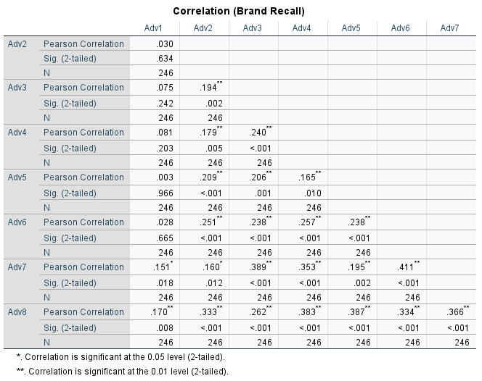

Table 1: Correlation analysis from SPSS of initial brand recall from advertisements shown.

Scatterplot 1: This scatterplot shows the late recall of the participants, where they checked the box saying “I do not recall this advertisement” overtime by the order of the advertisement, showing a positive linear trend.

Comparison Bar Graph A1: Each advertisement was categorized by their length, with 4 long advertisements and 4 short advertisements. This data is the same from Scatterplot 1, but sorted to show the difference between

Comparison Bar graph A2: This graph combines the total number of respondents who did not recall the advertisement from Comparison Bar Graph A1 into a total long term recall comparison.

According to Table 1 and the bar graphs above, there is a clear correlation on the different advertisements shown. Therefore, there is a difference in long advertisements and short advertisements in referral to recall, where longer advertisements were harder to recall than the shorter advertisements overtime. Scatterplot 1 shows that the more the participants watched the advertisements, the more they forgot on average the brand that they observed earlier in the process, as this questioning was for long-term recall. However the respondents considerably remembered less of the longer advertisements in comparison to the shorter advertisements, despite the order bias.

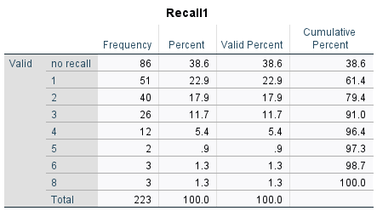

Table 2: This table shows the frequency of responses in relation to the immediate recall. It shows the valid percent and the percent of “1 – 8” – a respondent who recalled 1, 2, 3, 4, 5, 6, or 8 advertisements shown and “No recall” – a respondent who did not recall or recall correctly any advertisement brands shown. No participants recalled 7 advertisements, so there is no category for “7”.

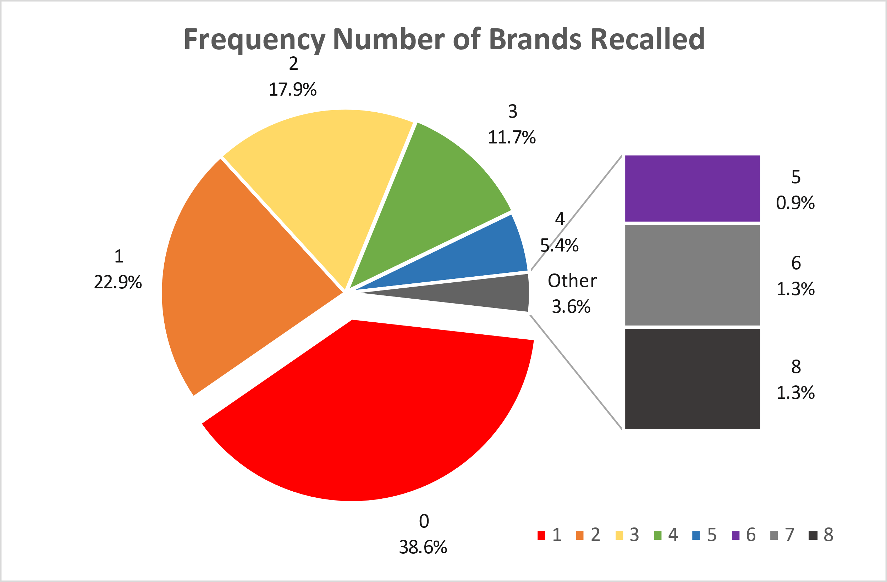

Pie Graph 1: This graph is a visual depiction of Table 2’s valid percentage

Table 2 and Pie Graph 1 shows the percentage of immediate recall. As shown above, 38.6% of participants did not correctly recall any advertisement brands shown. 22.9% of participants only could recall one brand correctly. This trend continues to decrease at an exponential level, where only 3 participants remembered all 8 advertisement brands shown. Even when prompted to list all the brands they remembered directly after being shown the group of advertisements, there was substantial difficulty remembering the brands.

Pie Graph 2: This graph is a visual depiction of how much on average did the participants think other participants were paying attention to the advertisements shown.

Each participant was also asked from a scale of 1 to 100%, how many other participants would be paying attention of 100% was the entire time and 0% was not at all. On average, this percentage paying attention on average was 49.88%, where participants think that other participants would be paying attention only half of the time.

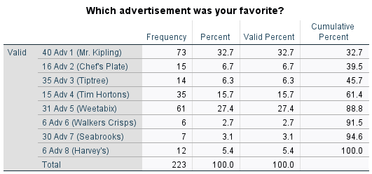

Table 3: This table shows the popularity of each advertisement through frequency, percentage, and valid percentage. The first number before the “adv X” is the duration (seconds) of each advertisement.

Pie Graph 3: This graph is Table 3’s valid percent visually represented. Each number that is not a percentage is how long (seconds) the advertisement was.

Comparison Bar Chart B1: This bar graph shows the breakdown comparison of the short advertisements over the long advertisement’s favoritism.

The longer advertisements had a higher favor than the shorter advertisements except the 30 second advertisement from Seabrooks and the 35 second ad from Tiptree. The shorter advertisements were less positively received in this data set. The outliers of the longer advertisements made the long advertisements overall more successful in favoritism compared to the shorter advertisements.

The following bar graphs are based on the Likert scale; Strongly disagree (1), disagree (2), Neither agree nor disagree (3), agree (4), Strongly agree (5). Participants were asked the following questions at the end of the survey:

* I would buy this product
* I was entertained by the advertisement of this product
* I would like or upvote this advertisement on social media
* I am interested in this brand
* I would share this advertisement with my friends
* I would share this advertisement with my family
* I would comment on this advertisement if I could

The following data shows the averages on the Likert scale for these questions on the individual advertisements as well as on average the short vs long advertisements.

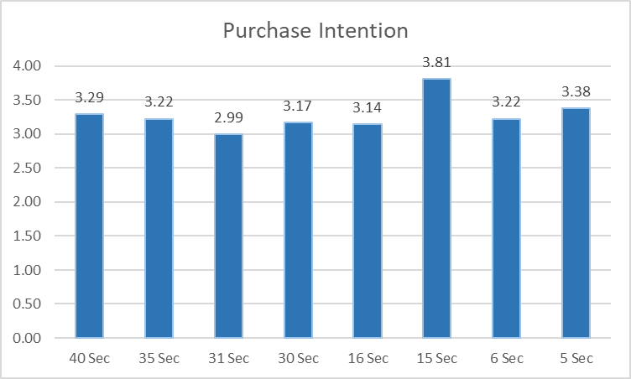

Bar Graph 1: This bar graph shows from 1 (Strongly disagree) to 5 (Strongly agree) on average how a participant felt about how likely they would buy the product shown.

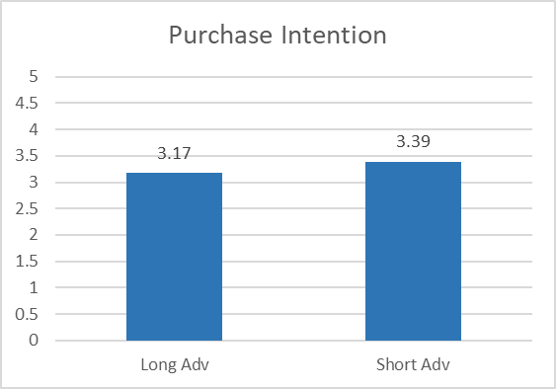

Bar Graph 1a: The means in Bar Graph 1 were averaged in their respective categories of either a short advertisement (5-16 seconds) or long advertisement (30+ seconds).

These graphs are the means of the responses of the Likert scale question “I would buy this product” by participants who recalled the particular advertisement and brand. Participants on average favored the short advertisements over the longer ones in terms of purchase intention.

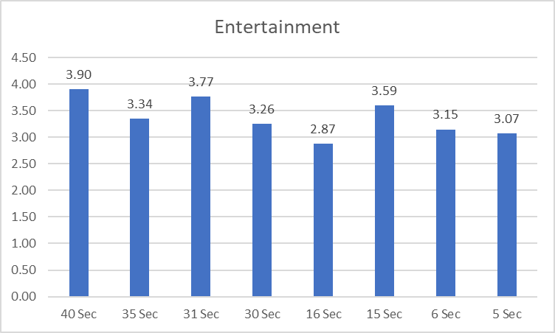

Bar Graph 2: This bar graph shows from 1 (Strongly disagree) to 5 (Strongly agree) on average how entertained a participant felt about the advertisement.

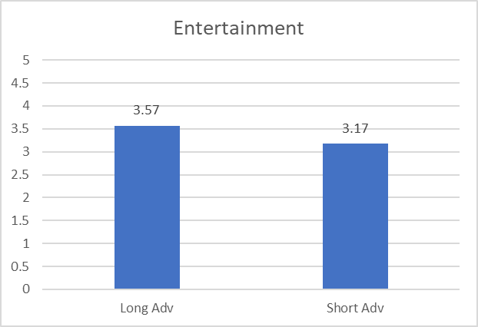

Bar Graph 2a: The means in Bar Graph 2 were averaged in their respective categories of either a short advertisement (5-16 seconds) or long advertisement (30+ seconds).

These graphs are the means of the responses of the Likert scale question “I was entertained by the advertisement of this product” by participants who recalled the particular advertisement and brand. On average, participants were more entertained by the longer advertisements.

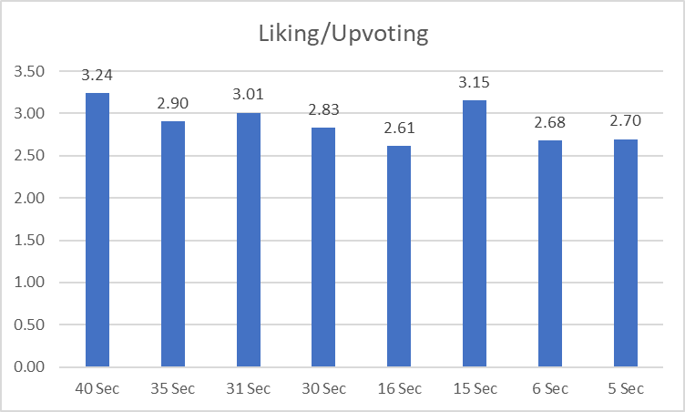

Bar Graph 3: This bar graph shows from 1 (Strongly disagree) to 5 (Strongly agree) on average how likely a participant would like or upvote the particular advertisement.

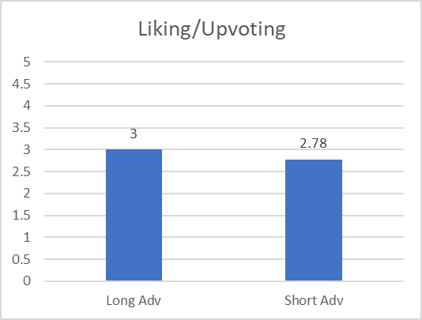

Bar Graph 3a: The means in Bar Graph 3 were averaged in their respective categories of either a short advertisement (5-16 seconds) or long advertisement (30+ seconds).

These graphs are the means of the responses of the Likert scale question “I would like or upvote this advertisement on social media” by participants who recalled the particular advertisement and brand. On average, participants were more likely to like or upvote the longer advertisements.

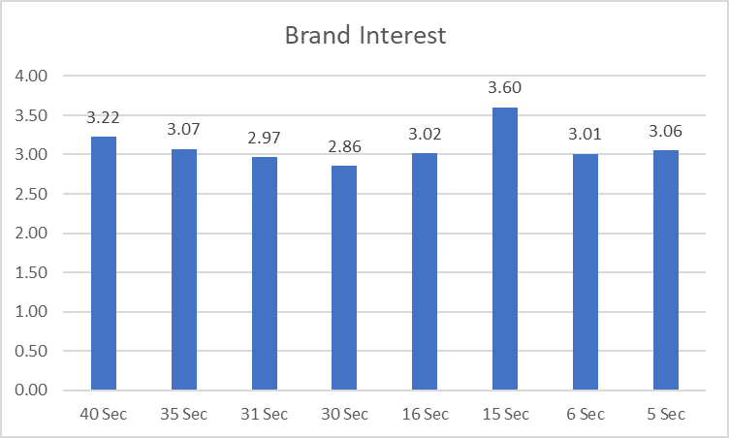

Bar Graph 4: This bar graph shows from 1 (Strongly disagree) to 5 (Strongly agree) on average how interested a participant was with the brand.

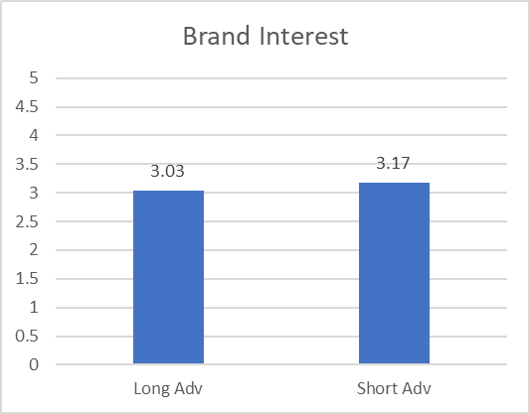

Bar Graph 4a: The means in Bar Graph 4 were averaged in their respective categories of either a short advertisement (5-16 seconds) or a long advertisement (30+ seconds).

These graphs are the means of the responses of the Likert scale question “I am interested in this brand” by participants who recalled the particular advertisement and brand. On average, participants were more interested in the shorter advertisement’s brand than the longer advertisements

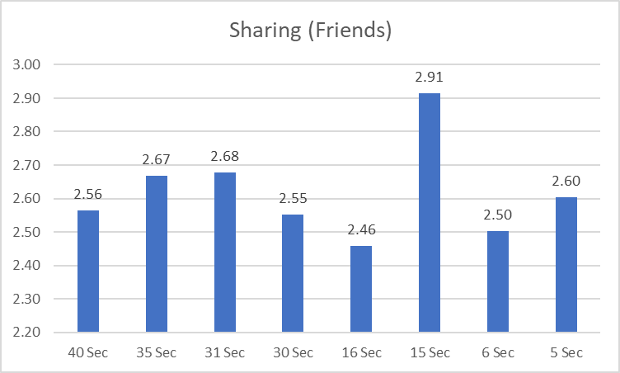

Bar Graph 5: This bar graph shows from 1 (Strongly disagree) to 5 (Strongly agree) on average how likely a participant would be to share this advertisement with a friend.

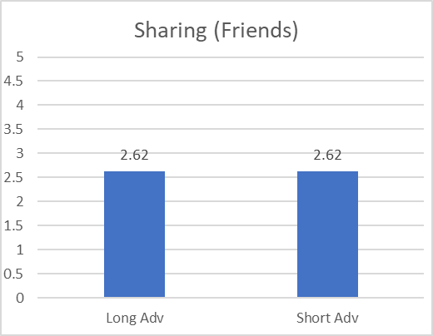

Bar Graph 5a: The means in Bar Graph 5 were averaged in their respective categories of either a short advertisement (5-16 seconds) or long advertisement (30+ seconds).

These graphs are the means of the responses of the Likert scale question “I would share this advertisement with my friends” by participants who recalled the particular advertisement and brand. The averages were the same, however the outlier in the shorter advertisements greatly sways the average. Most people would disagree and not likely share any advertisements with their friends.

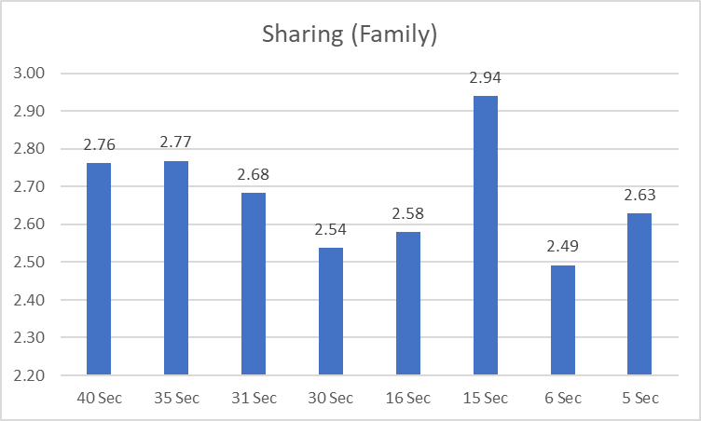

Bar Graph 6: This bar graph shows from 1 (Strongly disagree) to 5 (Strongly agree) on average how likely a participant would share an advertisement with their family.

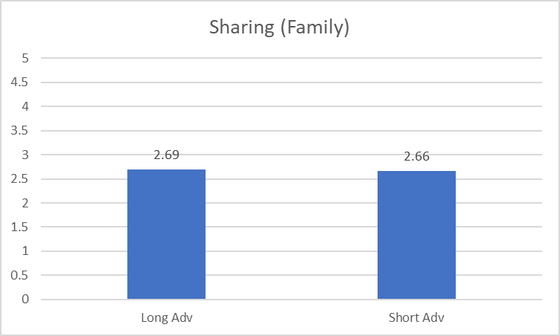

Bar Graph 6a: The means in Bar Graph 6 were averaged in their respective categories of either a short advertisement (5-16 seconds) or long advertisement (30+ seconds).

These graphs are the means of the responses of the Likert scale question “I would share this advertisement with my family” by participants who recalled the particular advertisement and brand. The averages are relatively negative, and on average the participants are less likely to share an advertisement with their family. However, they are more likely to share the longer advertisement than the shorter advertisement.

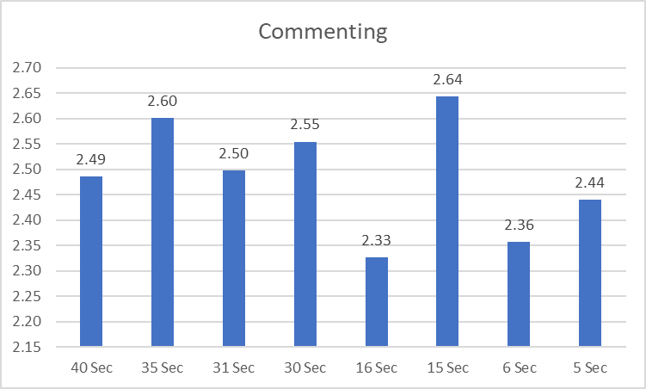

Bar Graph 7: This bar graph shows from 1 (Strongly disagree) to 5 (Strongly agree) on average how likely a participant would comment on the advertisement.

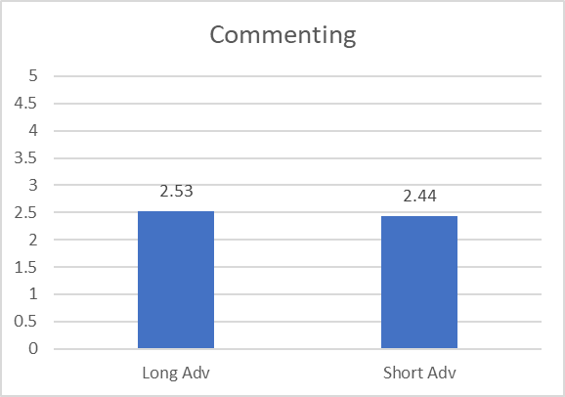

Bar Graph 7a: The means in Bar Graph 7 were averaged in their respective categories of either a short advertisement (5-16 seconds) or long advertisement (30+ seconds).

These graphs are the means of the responses of the Likert scale question “I would comment on this advertisement if I could” by participants who recalled the particular advertisement and brand. Most participants on average agree that they would not comment on an advertisement. However, if they did, they would more likely comment on the longer advertisement.

**Discussion**

Considering the vast majority of qualitative studies relating to attention economies and short advertising separately, the research conducted in this particular research is more quantitative focused but exploratory in nature. This research shows that not only does Generation Z have a shorter attention span when given a set amount of advertisements, they also show how to target certain aspects with short or long advertisements, depending on what a marketer needs.

Not many participants could remember the brands at the beginning, much less more than one. Approximately 38% of participants did not recall or correctly recall any brands from the video when asked directly after. This means that their attention span was already dwindling in the beginning. When participants tapped into their long term recall, there was still a difficulty for them to remember the longer advertisements in comparison to the shorter advertisements. Furthermore, the participants were confident on average that the other participants were paying attention about half of the time. Overtime, the participants remembered less and less of the advertisements overall, but there was a difference in long term recall between short and long advertisements.

Moreover, Shorter advertisements were more effective with immediate and long term recall in comparison to longer advertisements. Keeping in mind the significance of correlation, there is a trend of favoritism in longer advertisements in regards to entertainment value, liking, and sharing. Participants are also shown to have a higher interest in the brand itself and are more likely to buy the product of a shorter length. There are different distinctions and limitations to both shorter and longer advertisements where marketers can utilize the effective portions for their wants and needs. If marketers want an immediate purchase response, shorter advertisements are more effective. However, if marketers want to engage with consumers, longer advertisements are more effective.

**Limitations**

Not every person within the generation is going to behave exactly as predicted, however, these are generalized observations with significant correlations. The limitations placed on this particular research are the age generations, as this research is mainly focused on Generation Z, and the correlation of shorter attention spans within their particular attention economy. Attention spans for older generations may be impacted by cognitive functioning. Furthermore, Generation Z does include people from age 7, however, for the purpose of the study the data is focused on college-aged digital natives older than 18.

This survey was done online, and to limit the amount of distractions, we asked participants to put away distractions. Participant outliers with high timing on the video portion were discarded from the analysis to ensure the participant was truly paying attention to the advertisements. Furthermore, the video presented was not randomized for the participants, which can result in order bias. We have found these integers at a 95% confidence level, and the data is still has significant correlation.

There have been limitations in research found about the distinction between conscious and unconscious effects that can influence the quantification of the factors that affect a consumer’s brand awareness and purchase intention (Weibel, 2020). It is hard to define what could be a conscious or unconscious influence within a consumer’s mind regarding the advertisements they have been exposed to. However, we can use the proven methods above to influence both their unconscious and conscious mind without having to know the specific reasons that influence the immeasurable aspects.

**Future Research**

Given the ever-changing markets that businesses exist within, there is a constant need for evaluation and adaptation regarding advertisement strategies. There needs to be more research on Millennials in this area, as there were not enough participants in this study to properly asses their age group. There also needs to be more research on the implications of creating a distracting environment and having a less distracting environment and how that affects customer retention. In the television experiment that Weibel conducted, he did not have a control group without common distractions. If this research was to be conducted again, a control group is needed for further clarification and easy collection of more reliable quantitative data regarding distraction’s effects on advertising.

As related to informational overwhelm, there is a need for a longer study that observes the amount of media the participant consumes over time with study advertisements dispersed within. A short 10 to 15-minute survey can not fully capture the behaviors behind the true rate of consumption and the exact length. This can lead to more accurate observations of just how much time the participant consumers are spending online and possibly what type of information they are consuming more frequently. They also should look into varying the amount of information given to each participant and comparing the recall that they have over time-related to the advertisements the researchers present.

**References**

Abidin, C. (2020). “Mapping Internet celebrity on TikTok: Exploring attention economies and visibility labours.”*Cultural Science Journal, 12*(1), 77-103. [https://sciendo.com/ es/article/10.5334/csci.140](https://sciendo.com/%20es/article/10.5334/csci.140)

Anderson, K. E. (2020). “Getting acquainted with social networks and apps: it is time to talk about TikTok.”*Library Hi Tech News,*[https://www.emerald.com/insight /content/doi/10.1108/LHTN-01-2020-0001/full/html?casa\_token=6YfqX6bAmiIAA AAA:zCrlHQe\_PkQgjeD0zJ5GYk0HcE6sc6ZA4PJXHMJeF9c2t3XxcGyNXrydhzok55udDYqef35vFocQJq2oc\_-vhi\_DU8Q67ro7byG9IDJyjrx9b0O94co](https://www.emerald.com/insight%20/content/doi/10.1108/LHTN-01-2020-0001/full/html?casa_token=6YfqX6bAmiIAA%20AAA:zCrlHQe_PkQgjeD0zJ5GYk0HcE6sc6ZA4PJXHMJeF9c2t3XxcGyNXrydhzok55udDYqef35vFocQJq2oc_-vhi_DU8Q67ro7byG9IDJyjrx9b0O94co)

Chen, Yimin, Niall J. Conroy, and Victoria L. Rubin. "Misleading online content: recognizing clickbait as" false news"." *Proceedings of the 2015 ACM on workshop on multimodal deception detection*. 2015. [https://dl.acm.org/doi/pdf/10.1145 /2823465.2823467?casa\_token=-HYRzRWJHugAAAAA:aD5 jzGrQQomtzXvIUjKa2wD-y6hLpPv76fRadosGGPKYi9XG9phAGNsyJA XJ93cahlozlSoTo10IXA](https://dl.acm.org/doi/pdf/10.1145%20/2823465.2823467?casa_token=-HYRzRWJHugAAAAA:aD5%20jzGrQQomtzXvIUjKa2wD-y6hLpPv76fRadosGGPKYi9XG9phAGNsyJA%20XJ93cahlozlSoTo10IXA)

Falkinger, J. (2007). “Attention economies.”*Journal of Economic Theory, 133*(1), 266-294. [https://www.econstor.eu/bitstream/10419/76639/1/cesifo\_wp1079.pdf](https://www.econstor.eu/bitstream/10419/76639/1/cesifo_wp1079.pdf" \t "_blank)

Fischer, E., & Smith, A. N. (2020) “Pay attention, please! Person brand building in organized online attention economies.” <https://link.springer.com/article/10.1007/s11747-020-00736-0>

Kies, S. C. (2018). Social media impact on attention span.*Journal of Management & Engineering Integration, 11*(1), 20-27. [https://www.proquest.com/ docview/2316725647?pq-origsite=gscholar&fromopenview=true](https://www.proquest.com/%20docview/2316725647?pq-origsite=gscholar&fromopenview=true)

Kim, Woojae, Jungwoo Shin, and Youngsang Cho. "Is a “6-second” advertisement reasonable? Acceptable mobile advertisement length for consumers." *Telematics and Informatics* 74 (2022): 101875.

Kong, S., Huang, Z., Scott, N., Zhang, Z., & Shen, Z. (2019). “Web advertisement effectiveness evaluation: Attention and memory.”*Journal of Vacation Marketing, 25*(1), 130-146. <https://journals.sagepub.com/doi/pdf/10.1177/1356766718757272>

Lim, W. M., Gupta, S., Aggarwal, A., Paul, J., & Sadhna, P. (2021). “How do digital natives perceive and react toward online advertising? Implications for SMEs.”*Journal of Strategic Marketing,*, 1-35. [https://www.tandfonline.com/doi/pdf/10. 1080/0965254X.2021.1941204?casa\_token=3zPF9GCzq-UAAAAA:dI1W44EcDY7kOISwASAzuIeC8QSTocujvuXmt8H3N2FFPrXccx9Pq1dpJz81PEILwZIulX4ck7ohqA](https://www.tandfonline.com/doi/pdf/10.%201080/0965254X.2021.1941204?casa_token=3zPF9GCzq-UAAAAA:dI1W44EcDY7kOISwASAzuIeC8QSTocujvuXmt8H3N2FFPrXccx9Pq1dpJz81PEILwZIulX4ck7ohqA)

Munsch, A. (2021). “Millennial and generation Z digital marketing communication and advertising effectiveness: A qualitative exploration.”*Journal of Global Scholars of Marketing Science, 31*(1), 10-29. [https://www.tandfonline.com/doi/pdf/10.1080/2 1639159.2020.1808812?casa\_token=SREmbcqgGzsAAAAA:3PHz9vAlYqIAvfyjHhnvIl7AKCduFdAHS3WFFKWfRw3oVUT7y9vT-a9blPGWIAzEuUvW3bT3Ilrfgg](https://www.tandfonline.com/doi/pdf/10.1080/2%201639159.2020.1808812?casa_token=SREmbcqgGzsAAAAA:3PHz9vAlYqIAvfyjHhnvIl7AKCduFdAHS3WFFKWfRw3oVUT7y9vT-a9blPGWIAzEuUvW3bT3Ilrfgg)

Sen, A., & Sengupta, S. (2021). “Digital Revolution and Information Age: Emergence of Economies of Attention.”*Technology, 6*(3) [http://oaijse.com/Volume Articles/FullTextPDF/716\_16.\_DIGITAL\_REVOLUTION\_AND\_INFORMATION\_AGE\_(1).pdf](http://oaijse.com/Volume%20Articles/FullTextPDF/716_16._DIGITAL_REVOLUTION_AND_INFORMATION_AGE_(1).pdf)

Subramanian, K. R. (2018). “Myth and mystery of shrinking attention span.”*International Journal of Trend in Research and Development, 5*(1) http://www.ijtrd. com/papers/IJTRD16531.pdf

Sukri, S., & Wan Marzuki, Wan Muhammad Muizzudin. “The Relationship Between Online Advertising Strategies With Advertisement Effectiveness.”*Jurnal Evolusi, 2*(1) <https://eprints.kuptm.edu.my/2178/1/THE%20RELATIONSHIP%20BETWEEN%20ONLINE%20ADVERTISING%20STRATEGIES%20WITH%20ADVERTISEMENT%20EFFECTIVENESS.pdf>

Tresa Sebastian, Ann, et al. "Exploring the opinions of the YouTube visitors towards advertisements and its influence on purchase intention among viewers." *Cogent Business & Management* 8.1 (2021): 1876545. [https://www.tandfonline.com/doi/ full/10.1080/23311975.2021.1876545?scroll=top&needAccess=true](https://www.tandfonline.com/doi/%20full/10.1080/23311975.2021.1876545?scroll=top&needAccess=true)

Varan, D., Nenycz-Thiel, M., Kennedy, R., & Bellman, S. (2020). “The effects of commercial length on advertising impact: what short advertisements can and cannot deliver.”*Journal of Advertising Research, 60*(1), 54-70. http://www.journalofadverti singresearch.com/content/60/1/54

Weibel, D., Di Francesco, R., Kopf, R., Fahrni, S., Brunner, A., Kronenberg, P., Lobmaier, J. S., Reber, T. P., Mast, F. W., & Wissmath, B. (2019). “TV vs. YouTube: TV advertisements capture more visual attention, create more positive emotions and have a stronger impact on implicit long-term memory.”*Frontiers in Psychology, 10*, 626. https://www.frontiersi n.org/articles/10.3389/fpsyg.2019.00626/full